If you or someone you know is in immediate danger, please call Emergency Services:  Akwesasne Mohawk Police Service -  (613) 575-2000  Saint Regis Mohawk Tribal Police Department –  (518) 358-9200 |  |  | 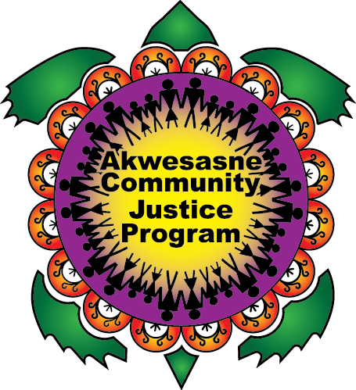

Contact Us:
Ronwatikes Victim Services
Akwesasne, QC H0M 1A0
troy.francis@akwesasne.ca
Office – (613) 575-2340 ext. 3533
Cell – (613) 360-8897

Ronwatikes

Victim Services
  - “We stand with Them”

What are some of our Services?
- Advocacy
- Emotional Support
- Referral Service
- Safety Planning/Safety Measures
- Assistance with pre and post stages of the diversion and old ways conferencing
- Court Preparation/Debriefing
- Court Accompaniment
- Information on the Criminal Justice System, Victim’s Rights, and Investigative Processes
- Help with financial benefits and/or restitution

All of our services are confidential and are customized to fit the needs of the victim.

Contact Ronwatikes Victim Services if YOU or Someone you know has experienced one of the following:
- Abduction
- Assault
- Criminal Harassment
- Domestic Violence
- Elder Abuse
- Homicide
- Human Trafficking
- Missing Persons
- Motor Vehicle Accident
- Natural Disaster
- Robbery
- Sexual Assault
- Any Tragic Circumstance
Ronwatikes Victim Services is able to help all victims of crime and/or tragic circumstance.

Mission Statement

“To meet, assess, and facilitate service needs culturally appropriate for the victim and their family. To give those who have been harmed a voice again and for that voice to be heard.”

