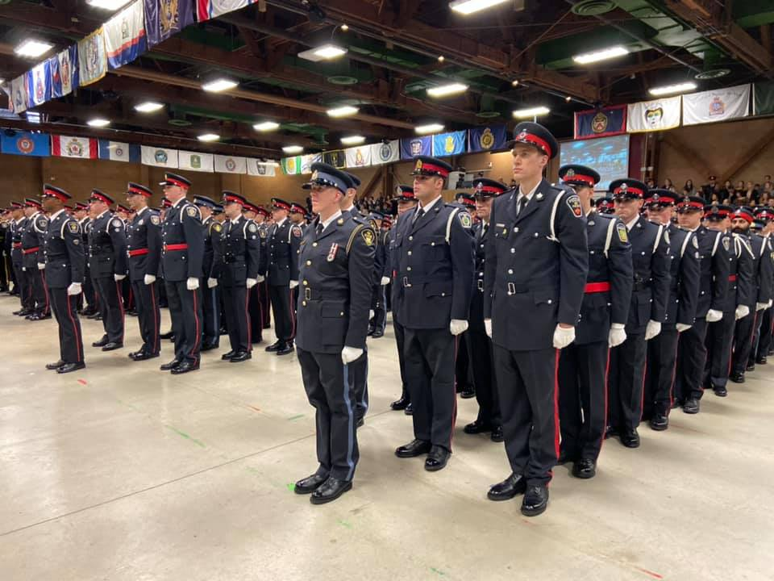

AMPS Strategic Plan

2019-2022
January 14, 2020

Mohawk Council of Akwesasne
Chelsea Francis
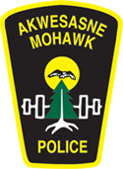

Akwesasne Mohawk Police Service

Message from the Chief of Police:

Shé:kon/Hello;

As the Chief of Police, I am pleased to present to you the Akwesasne Mohawk Police Service Strategic Plan for the next 5 years, 2020-2025.

Our plan is aligned with the Mohawk Council of Akwesasne’s plan to assure that the community receives the best possible service. Our goal is to provide a high quality of service to the community, and to provide members and visitors a safe place to live and thrive in. Our new plan is a single guiding document that identifies the organization’s priorities and represents our vision for the future.

The plan includes elements of the MCA’s strategic plan, and includes elements of our employee contributions and participation. Additionally, the plan includes our new Mission and Vision/Values statements that demonstrate our commitment to providing a truly safe living environment for all Akwesasronon and our visitors.

A review and prioritization process will occur annually to ensure our goals and activities set out in this plan are updated and relevant. We will be working together to achieve these goals, as well as setting out new goals and activities as necessary.

I encourage you to review our Strategic Plan initiatives, which reaffirm our commitment to proactively and responsively provide police services that enhance safety and the quality of life in the community of Akwesasne.

Nia:wen,

Chief Shawn Dulude

Improvement today, for a better tomorrow.

Strategic Planning is an organizations process on defining its strategy, or direction, and making decisions on allocating its resources to pursue this strategy. Strategy has many definitions, but generally involves setting strategic goals, determining actions to achieve the goals, and mobilizing resources to execute the actions. A strategy describes how the ends (goals) will be achieved by the means (resources).

About Strategic Planning: Propelled by its citizens, administration and leaders, strategic planning is meant to guide a society or community towards a common vision by making improvement to all aspects of life important to that society or community. Through this process, it must be recognized that the needs in certain areas may be of higher priority than others.

Methodology for Current Strategic Plan: Over three separate occasions, Council, along with Directors and Program Leads participated in facilitated sessions designed to specify and prioritize key strategies and initiatives necessary to achieve the goals compiled in Akwesasne’s Comprehensive Community Plan (CCP). Utilizing the CCP as the framework of input from community members, the MCA established the key strategies and initiatives

This document differs from the strategic plans created by MCA in that the initiatives and strategies have been developed to achieve the goals, desired outcomes and progress indicators set out in Akwesasne’s Comprehensive Community Plan and Akwesasne National Indicators Framework as they pertain to the Akwesasne Mohawk Police.

Values and Mission Statements
The Akwesasne Mohawk Police Service’s vision and mission statements were established by the AMPS leadership and staff. Together these statements of declaration are to guide the work and activities of the AMPS with clear goals to strive for as they serve the People and community of Akwesasne. The new values and mission statements for the AMPS are as follows:

VALUES:
Honesty, Integrity and Accountability to the community of Akwesasne.

MISSION:
The Akwesasne Mohawk Police Service’s Mission is to serve the community members on a personal level in the utmost professional manner, and by enhancing the community safety and well-being.

AMPS Team Collaboration Notables:
The importance of Strategic Planning as a team is key in ensuring the success of the plan, and the organization. These are the basis for the development of the goals and initiatives laid out in this plan:

Team perspectives on the Purpose are as follows:
- To formulate strategies and to identify objectives and tasks;
- To develop strategies for achieving a common goal;
- Serve as an idea for direction related to operations;
- To make a plan for AMPS moving forward for the next 3-5 years;
- To set goals for all Units;
- To improve service;
- To develop clear, measurable and attainable goals;
- To identify organizational goals and the methods to achieve them.

Your Role in this plan is also a key aspect of a successful implementation:
- To determine how AMPS gets there;
- To monitor the progress;
- To motivate;
- To provide more ideas on how to achieve success;
- To lead your group to achieving those goals, and to better serve the community;
- To ensure the goals and plans are being met;
- To assist in the development of a plan for the years to come;
- To ensure effective communication with all team members, and other supervisors.

Areas of Improvement from the previous plans:
- Create goals that are realistic and attainable;
- Keep the community in mind at all times and points of implementation of these goals;
- Gain as many employees input as possible prior to finalizing the plan;
- Create unity;
- Set small goals to work on with a time line;
- Ensure communication throughout the entire department at all levels;
Goals and Activities
The Akwesasne Mohawk Police Service will strive to accomplish the below goals and activities in order to successfully achieve the objectives outlined in the Mohawk Council of Akwesasne Strategic Plan 2018-2022.

The time lines expected to achieve each activity are as follows:
- URGENT: 1-2 years
- IMPORTANT: 2-3 years
- TO-DO: 3-5 years

Goal #2: Live in a Safe Community
Objective 1: Environmental Enhancements
Urgent Important To-Do
Implement Access Code to the AMPS Station
Implement Life Guard Summer Student at Swimming areas
Install signs with all contact information to AMPS throughout community
Obtain a Plate Reader for the AMPS Department
Incorporate side walks in all districts for public safety (Kawehnoke and Tsi Snaihne)
Work with the Akwesasne Safety Patrol on recommendations they have for the community
Install/implement cameras on all MCA & public buildings
Complete internal environmental assessment on each district
Increase AMPS Station security
Ensure all schools in each district have and know their own security systems

Objective 2: Increase Public Safety Information Sessions
Urgent Important To-Do
Post monthly Community Support (CS) events at the beginning of each month
Develop a communication strategy
Create and develop Social Media pages (Instagram)
Increase Social Media Activity
Provide Public Information Sessions
Increase radio, newspaper and social media advertisement for information sessions
Provide Education sessions on processes such as Law and Security classes
Objective 3: Border Crossing Education
Urgent Important To-Do
Support cultural sensitivity training to take place more often
Provide educational sessions on border crossing laws and rules
Provide presentations to young and new drivers on Respecting Law Enforcement Agencies and Authorities

Objective 6: Explore opting into the Police Services Act
Urgent Important To-Do
Develop a Succession Plan for AMPS
Prepare for opting into the new PSA
Educate Members; officers and dispatch on the PSA

Objective 7: Create a Vulnerable Persons Database
Urgent Important To-Do
Designate an AMPS member to sit at Roundtable Meetings
Flag Vulnerable Persons the same as DVHRO with same process (Consent, Call-out for persons)
Flag RMS persons as “Special Needs”
Obtain an In-Car Computer System for better access to databases
Develop GIS specifically for AMPS
Research NICHE program for implementation and use

Objective 10: Create Neighborhood Watch Program
Urgent Important To-Do
Complete Research and begin Implementation
Create and implement Road Signs
Educate the Community to build awareness of program
Implement stickers that advertise program on all patrol cars

Goals and Activities
The Akwesasne Mohawk Police Service has established its own objectives outside of those outlined in the MCA Strategic Plan. Below are the activities the AMPS will strive to accomplish in order to successfully achieve the objectives outlined in the Akwesasne Mohawk Police Service Objectives.

AMPS Objective 1: Maintain and Increase Public Confidence
Urgent Important To-Do
Provide annual Surveys to the community (Sept/Oct)
Encourage Officers to stop at schools during recess and in classrooms
Create a Police Obstacle course for community events
Implement an officer at bus drop off locations
Follow up with victims of crime more frequently
Implement a PowWow Resource Table
Implement “Coffee with a Cop” events ($100 gift cards)

AMPS Objective #2: Strengthen Operational Capacity through
Urgent Important To-Do
Hire a Criminal Analyst
Research Calls for Service, and Staggered Shifts
Hire more civilians to optimize resource distribution (outsourcing and administration restructuring)

AMPS Objective #3: Optimize Intervention Strategies Commuters
Urgent Important To-Do
Utilize and develop relationship with Seaway Valley Crime Stoppers
Increase media presence in regards to Crime Stoppers
Provide an ATV Safety Course
Provide a Boat Safety Course

AMPS Goal #4: Maintain a Safe Living Environment and Objective #5: Fight Against Street Crime and Local drug Enforcement
Urgent Important To-Do
Increase patrol times out of cruisers
Increase number of search warrants issued
Ensure the most up-to-date training is provided to maintain police competencies
Increase number of surveillance cameras throughout community
CTEPD Trg. Officers
Increase accessibility of Crime Stoppers to community members by providing a daily hotline
Increase the number of QCDSASW (?)
Increase community awareness of Crime Stoppers
Schedule monthly Intel Meetings between DISGT and Sergeants

Evaluation for AMPS Strategic Plan attached as a supplementary document.

